Using the American Institute of Physics Microsoft Word Submission Templates for Conference Proceedings
Authors who plan to publish papers in the AIP Conference Proceedings series and would like to use Microsoft Word to prepare their papers may find the AIP Paper Preparation Toolkits convenient. These templates make formatting your paper less time-consuming for you. Using the templates also ensures that your paper meets the AIP formatting requirements. You will be able to download the templates from the http://proceedings.aip.org/proceedings web site, click on the
Authors - MS Word link.
Authors who do not have access to MS Word will follow the existing guidelines for publication; pdf files of the Author Instruction Booklets can be found at http://proceedings.aip.org/proceedings, click on
Authors - Author Instructions, and choose the correct format for your paper. If you are unsure about the correct format, please contact your Volume Editor.

Requirements to Use the Paper Preparation Tools
Microsoft Word for Windows
AIP Paper Preparation Toolkit

How the Paper Preparation Tools Work
The Paper Preparation Toolkit consists of Word templates that you will install on your computer. Templates are blueprints that Word follows when providing formatting options in your documents. Templates also contain Styles for paragraphs, page layout, tables, and so on. Templates can save you time and ensure consistency within a document and between documents.
Once installed, you will be able to choose an AIP format for your paper. You will use the styles and macros built into the template to format each section of your paper. As an example, you will use the Abstract style to format the abstract of your paper.

Rules for Paper Preparation
Things to avoid:
Don’t place page numbers anywhere in your paper. AIP will place page numbers on the page when your paper goes to print.
Don’t modify the styles in any of the Toolkit templates.
Don’t change the margins on your pages.

Things to do in order to create a well-formatted paper:
Do use the styles provided for each standard portion of the paper.
Do use the AIP macros provided for creating common elements

Installing the Paper Preparation Toolkit
To install the Paper Preparation Toolkit, you will need to copy the Toolkit files into the Word User templates folder.
- To Install the Paper Preparation Toolkit:
- Start Word.
- Choose Tools, Options… from the menu.
- Select the “File Locations” tab if it isn’t already selected.
- Select the “User templates” line of the list of locations.
- Choose the Modify button.
- From the “Folder Name” line at the bottom of the dialog box, write down the location of the “User template” files.
e.g., C:\Users\Urs\AppData\Roaming\Microsoft\Templates
You need to know the location of the User templates. Do not make any changes to Word at this point.
- Choose Cancel to close the dialog box.
- Exit from Word and access the AIP Conference Proceedings web site on the internet: http://proceedings.aip.org/proceedings
- Click on Authors - MS Word and click here.
- Decide which paper size you use to print:
U.S. Standard letter size paper or Standard A4 paper
- AIP Conference Proceedings are published in different formats. Select the appropriate template for the format you need.
- Click on the file of your choice with the right button of your mouse. Choose the Save Link As option from this menu and choose the location you determined in Step 6 above.
- Start Word again.
- Choose File, New. You should see the AIP template available for use.

Using the Paper Preparation Toolkit Styles
These tools work best when starting a new paper. If you are comfortable using Word, you can apply the templates provided in the Toolkit to an existing paper.
When you open one of the templates, you will see sample text with appropriate formatting.
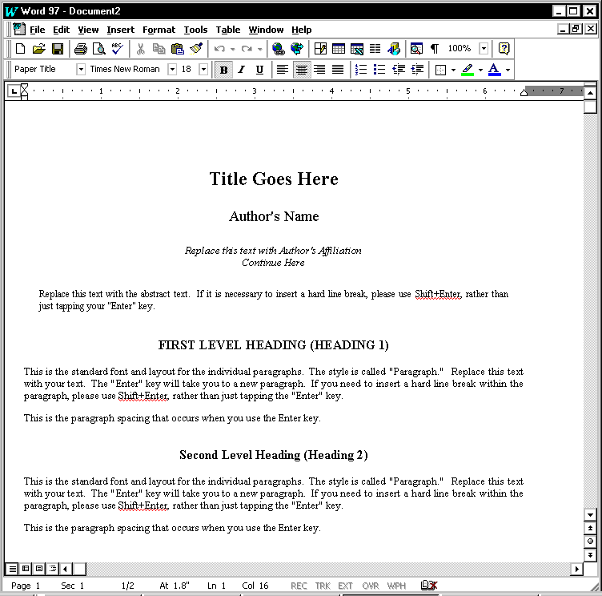
The simplest way to use the toolkit templates is to replace the sample text with real information. Be careful to only select the text you want to replace before you begin entering your own text.
To Start a New Paper:
- Start Word.
- Choose File, New. You should see the AIP template available for use.
- Open the appropriate AIP template.

To Replace the Paper Preparation Toolkit Sample Text:
- Select the sample text that you want to change.
- Type in the replacement text.

To Add New Headings, Captions, and Other Special Text:
- Within the document, type the new text.
Headings and other special text must be at the start of a new line.
- Make sure the blinking cursor is within the text to be changed.
- Choose the appropriate format from the style list.
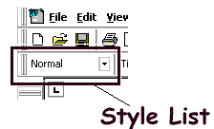
Style List box
If you are still entering new text for the paper, you may have to change the style for the next paragraph to “Normal.”

Using the Paper Preparation Toolkit Macros
The AIP Toolkit provides macros to automate some parts of producing a paper.
Whenever possible, use the macros provided for the following tasks:
Creating tables.
Creating placeholders for figures and references.
Deleting tables in a double-column format.
Making the columns on the last page of a double-column document even.

Using the AIP Macros
The AIP macros are located on a new menu found in papers written using the AIP toolkit. These menus work like the other menus found in Word.
To Use the AIP Menus:
- Move the blinking cursor to the place where the new item should be.
- Choose AIP from the menus.
- Choose the appropriate menu item.

Macros in Single-Column Templates
Menu Choices | Description
Insert 2-Column Table  Insert 3-Column Table  Insert 4-Column Table  Insert 5-Column Table | These macros place pre-formatted tables into your papers.
Add a Placeholder for a Figure | This macro will insert a placeholder for a figure and the figure caption.
Enter a Reference to a Book  Enter a Reference to a Paper in a Book  Enter a Reference to a Paper in a Journal  Enter a Reference to a Paper from a Conference | These macros insert placeholders for different types of references into your paper. These references should all be placed at the end of the paper. Reference numbers will appear automatically. However, you will have to manually place references to these items within the body of the paper itself.

Macros in Double-Column Templates
Menu Choices | Description
- Delete Current Single-Column Section | To create tables or figures that span across the entire page, Word 97 needs special section breaks placed before and after the table or figure. Manually deleting the table or figure will not delete the section breaks. Also, manually deleting the section breaks in the wrong order will cause formatting problems.  This macro highlights the current section and prompts for confirmation before finishing the deletion.
- Insert 2-Column Table  - Insert 3-Column Table  - Insert 4-Column Table  - Insert 5-Column Table | These macros place pre-formatted tables that span the entire page into your papers.
- Insert 2-Column Table within the Current Column  - Insert 3-Column Table within the Current Column | These macros place pre-formatted tables that span a single column into your papers.
- Add a Placeholder for a Figure | This macro will insert a placeholder for a figure and the figure caption.
- Add a Placeholder for a Figure over Both Columns | This macro will insert a placeholder for a figure that spans the entire page.
- Enter a Reference to a Book  - Enter a Reference to a Chapter in a Book  - Enter a Reference to a Paper in a Journal  - Enter a Reference to a Paper from a Conference | These macros insert placeholders for different types of references into your paper. These references should all be placed at the end of the paper. Reference numbers will appear automatically. You will have to manually place reference to these items within the body of the paper itself.
- Even Columns at End | This macro causes the columns to be even at the bottom of the last page.

