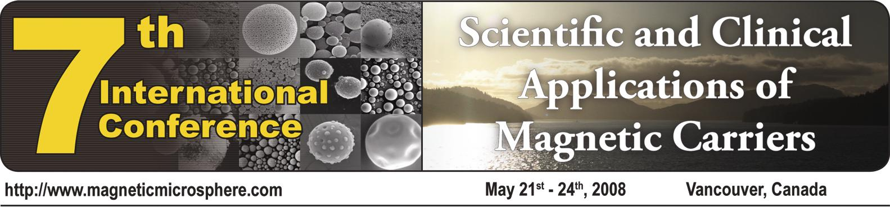

July 28, 2026

FIRST NAME LAST NAME
YOUR INSTITUTION
YOUR ADDRESS
YOUR CITY WITH ZIP CODE
COUNTRY

Invitation to the 2008 Magnetic Carrier Conference in Vancouver, Canada

Dear Mr/Ms/Prof/Dr LAST NAME:
It is a pleasure to invite you, Mr/Ms FIRST NAME LAST NAME, to our 7th International Conference on the Scientific and Clinical Applications of Magnetic Carriers. Our meeting will take place from May 20-24, 2008 in Vancouver, Canada. We are looking forward to have you report your newest research in the field of magnetic carriers with us!
If you need more information, please visit our website at www.magneticmicrosphere.com or e-mail me directly at uhafeli@interchange.ubc.ca.

With best wishes,

Prof. Urs Hafeli
Chairman, 7th International Conference on the
Scientific and Clinical Applications of Magnetic Carriers
Faculty of Pharmaceutical Sciences, University of British Columbia
2146 East Mall, Vancouver, BC V6T 1Z3, CANADA

